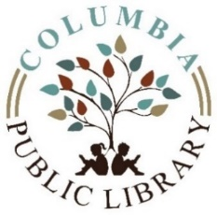 Executive Meeting Agenda

Columbia Public Library Board of Trustees

April 23, 2024

6:30 p.m.

* Call Meeting to Order
* Enter Executive Session.
  + 5 ILCS 120/2 (c )(1) Appointment, Employment, Compensation, Discipline, Performance, or Dismissal of Specific Employees of the Public Body