**How to Make a Library Card Holder?**

September is Library Card Sign Up Month! Celebrate by making your own personal library card holder. This could be a fun project for the kids or whole family. If you have that routine place to put your library card, your less likely to lose it and if the family keeps their cards together, you know which one is yours!

**Instructions:**

**Materials:** • 2 pieces of cardstock or weighted paper • yarn/ribbon • whole punch • Pencil and eraser • Scissors • Crayons, markers, or colored pencil.

## Make it!

1. Print out template onto a heavy sheet of paper or cardstock for tracing.
2. Cut around the outline of the library card holder. *(Do not cut the dotted lines.)*
3. Get a piece of weighted paper or cardstock. Lay the library card holder template on your paper, hold it down with one hand, and then trace around it by pressing your pencil against the edge of the template. Draw all the way around the template.
4. Cut out your traced library card holder.

## Customize it!

1. Before designing your library card holder, make sure you place a piece of paper under it. *Just in case you color off the edge, you do not want to color on the table.*
2. Next, color or draw designs on both sides or only one side of your library card holder with crayons, colored pencils, marker, etc.

## Make it Portable!

1. Finally, take your template and match it up with your library card holder. You are going to use the template to help you fold your library card holder. *If you have only one side of your library card holder designed, be sure to match the template up with the side you designed on your library card holder.*
2. Place the template side down and begin folding over the tabs of your template and library card holder on both sides, then fold the longer end over. Use the dotted lines as your guide to know where the folds happen.
3. Once the long end is folded over, remove your template. Make sure both tabs are folded between the short end and long end of your library card holder. *Also, be sure the tabs are folded towards the plain side of your library card holder, if it is designed only on one side.*
4. With glue or tape seal the outer edge of your tabs, connecting the short end and long end. *(If you used glue let dry before next step.)*
5. **Optional:** Once your library card holder is finished, you could punch some holes on the top two corners of our library card holder. Then, cut some yarn the length of a necklace, string it through the two holes, and tie the ends of the necklace into a secure knot.

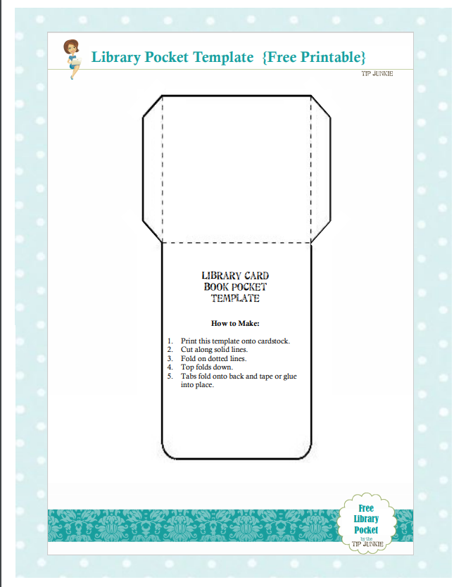

Free Library Card Book Pocket Template Printable. Martin, Devon (2016, April 16). Retrieved from https://tipjunkie.com/free-library-card-book-pocket-template-printable/